The Tartan Tribune
November 2020 Volume 1: Issue 3
Happy November! Check out everything that’s happening in the Highland Dance world this month.
If you have any questions or suggestions, please email sdnbpresident@gmail.com.

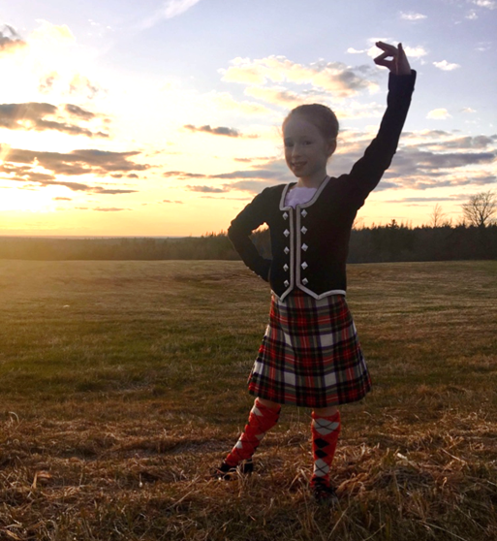 | SDNB Dancer Photo of the Month – Myra Bleakney  Meet Myra! She is a Novice dancer in New Brunswick and has been dancing with Highland Intensity Dance School in Sussex, NB for 3 years. Myra loves dancing with all her friends in class and really likes dancing the Flora.  Well done Myra, and thanks for being a great addition to the New Brunswick dance community!  If you’d like to feature your dancer, please submit photos and information to you'd like to sdnbpresident@gmail.com
Useful Resources
ScotDance New Brunswick website - https://www.scotdancenb.com/
ScotDance New Brunswick on Facebook - https://www.facebook.com/ScotDanceNB
ScotDance Canada website - http://scotdance.ca/
ScotDance Canada on Facebook - https://www.facebook.com/scotdancecanada
Heart of the Highlands Too Dance Supplies - https://www.facebook.com/heartothtoo
Scotia Sole Dance Supplies - https://www.facebook.com/ScotiaSole
Tartantown Dance Supplies - https://www.tartantown.com/

Meet Your ScotDance New Brunswick Dance Professionals!  Our next SDNB professional to introduce is our Secretary, Lindsay Gaunce!  A few fun facts about Lindsay:  - Number of years dancing: I’ve been dancing for 25 years.  - Number of years teaching: I’ve been teaching dance for 11 years  - Number of years volunteering with ScotDance New Brunswick: I began volunteering with SDNB 5 years ago and am continuing in my third term as SDNB Secretary.  - Favourite thing about Highland Dance: I love that there is both a competitive aspect and a performance aspect to our sport. I also find it interesting that even though highland dance is in various different parts of the world, we are such close-knit community | 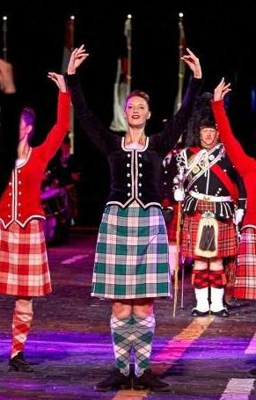
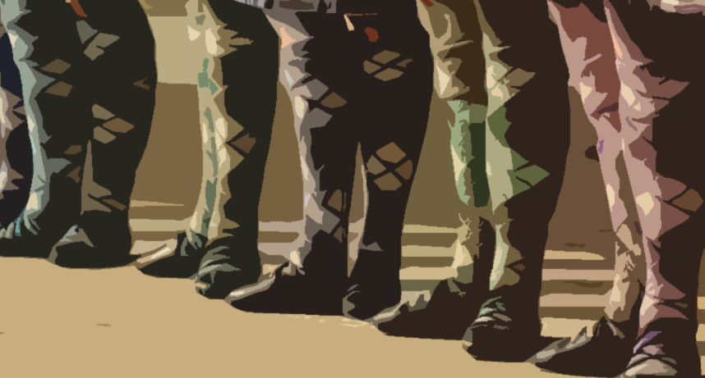 | Practice Challenge of the Month – Choreography Challenge!  Get your choreography caps on! We will be assigning each dance school a portion of a tune to choreograph to. We’ll then gather videos and piece them together for a full choreographed ScotDance New Brunswick piece. We may not be able to dance together, but we can still create together!
October Pas de Basque Challenge Winners:
New Brunswick Dance School: Highland Intensity Dance School, Sussex
New Brunswick Dancer: Sophie Bowles, Fredericton (4,750 Pas de Basque)

Congratulations to all our NB dancers and dance schools that took part! Together, our New Brunswick dancers completed 38,856 Pas de Basque in total. Our winners will be featured in the December issue of our newsletter! Stay tuned!

Upcoming Events
ScotDance New Brunswick Online Workshop – Saturday, November 28th
We are super excited to host a full day of workshop sessions on Saturday, November 28th! Guest instructors include: Larissa Godin, Ashley Stowkowy, Ellen Cameron, Joy Tolev, and more!!

Price for Primary: $7.50
Price for Pre-Premier/Premier: $15.00

Fill out your online registration here to secure a spot: https://docs.google.com/forms/d/1NPDCQHVv3h-aTHs4kcQ3O2JvPz4R5MX06O-5C_fvez0/edit?usp=sharing

Full schedule is as follows:
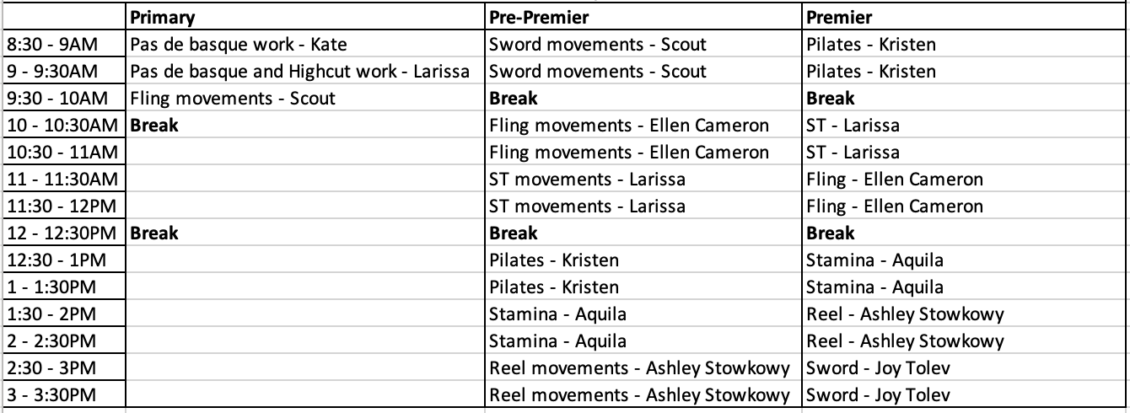

Scotia Sole Costume Swap – Saturday, November 21st

When: Saturday, November 21st, 2020
Where: 164 Kingswood Drive, Hammonds Plains, NS (by appointment only, contact Scotia Sole to book)
Admission: donations for Feed Nova Scotia

Get access to used costumes, ghillie fittings and on-site costume alternatives and consultations! There will be COVID restrictions in place at this event, but it will be a great opportunity to shop for dance items you’ve been looking for.

