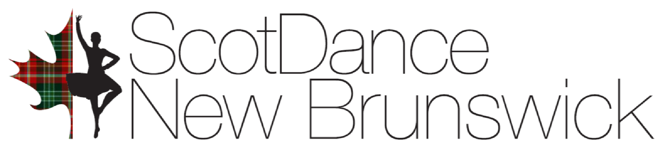
2026 ANNUAL SCHOLARSHIP PROGRAM - Reference Letter

Scotdance New Brunswick provides an annual Scholarship Program, the aim of which is to encourage and financially assist N.B. dancers in their goals of improving their dancing abilities & striving for excellence in Highland Dancing.

Applicant name:
Referee’s name:
Relationship to applicant:
If a highland dance teacher, please confirm that this applicant has been dancing in N.B. for at least 2 years. Yes __ Scotdance Canada member number:

Once completed, please submit forms via email to: sdnbscholarship@gmail.com
Deadline for applications : April 15, 2026

Applicants for these scholarships are assessed on their accomplishments in dancing, participation in competitions & community activities, benefits they have obtained from highland dancing, motivation to set goals, and financial need.

Please describe how you feel the applicant meets criteria for this award:

